



We can 3

Name: ……………………………………………………………….
Class: …………………………………………………………………

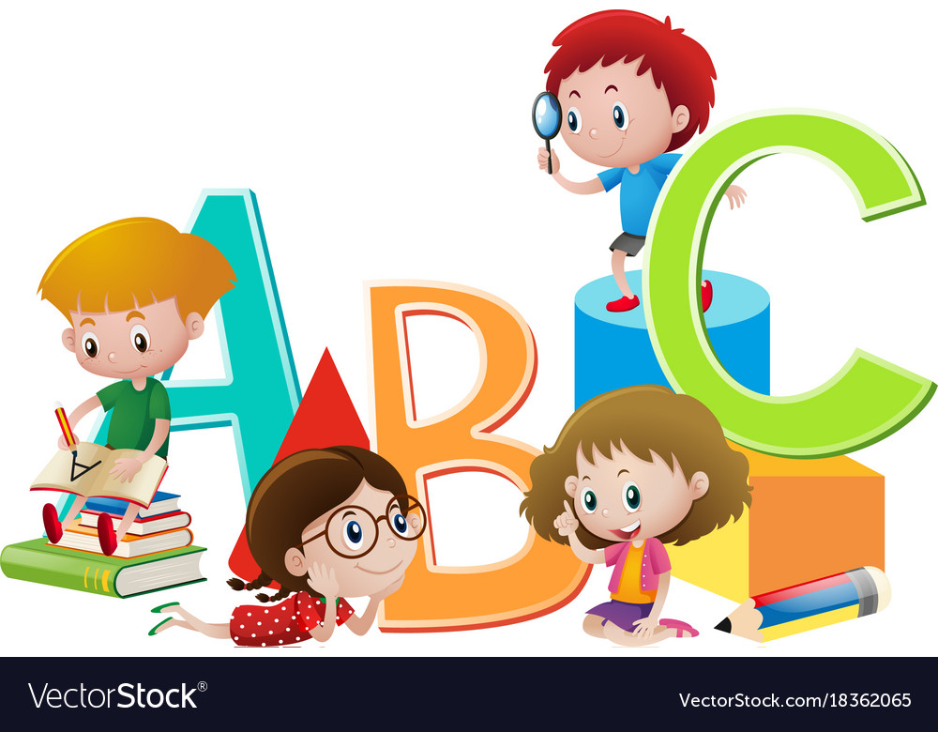
Prepared by:
Dr. Nadia AlGhamdi

Teacher’s notes

Unit 5
Unit 6
Unit 7
Unit 8

What time is it?
U5: Yesterday & Today Finding out time Date: / /1445H H

It is | o’clock | one  two  three  four  five  six  seven  eight  nine  ten  eleven  twelve
It is | 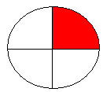  15 min
It is |   30 min
It is |   45 min

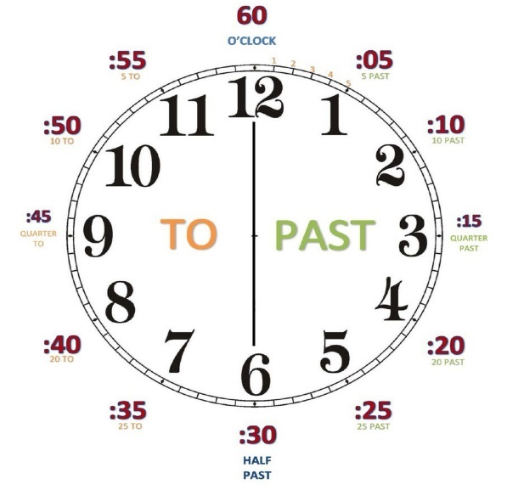

- What is the time?

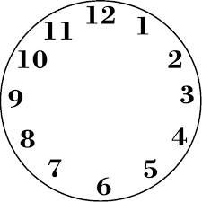  1 | 2 | 3 | 4
a. five o’clock | a. six o’clock | a. eleven fifteen | a. eight o’clock
b. one ten | b. eight thirty | b. two o’clock | b. three thirty
c. six thirty | c. five forty | c. ten thirty | c. four forty

- Read the time then draw hands on the clock

1 | 2 | 3 | 4
Three thirty | Seven fifteen | Ten forty five | eight o'clock .
- copy :


I usually get up at five o'clock.

U5: Yesterday & Today Grammar in Action Date: / /1445H
Daily Activity
 |  | 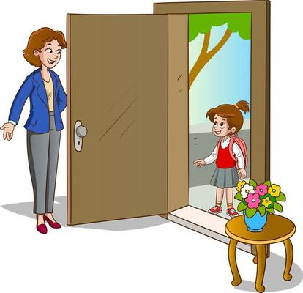 |  |  | 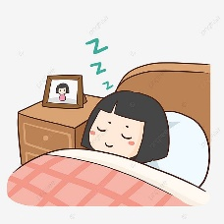
get up | eat lunch | come home | do my homework | take a bath | go to bed

- Write the past tense forms:
- I eat lunch . ...........................................................................................
2- I go to bed. ...........................................................................................

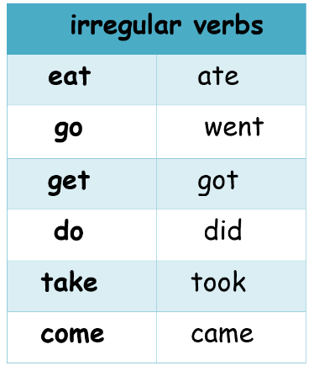
- Choose the correct answer :
- I usually ( get - got ) up at five o'clock.
- Yesterday I ( get - got ) up at five o'clock. 3- I usually (do – did) my homework at 4 o'clock .
4- Yesterday I (do – did) my homework at 4 o'clock . 5- I usually (took – take) bath at 9 o'clock .
6-Yesterday I (took – take) bath at 9 o'clock .

- Rearrange the words to make sentence in the past tens:
1- ate – lunch – I .......................................................................................................
- came – They – home ..............................................................................................

- copy :

Yesterday, I got up at five thirty.

U5: Yesterday & Today Rhythms and Reading Date: / /1445H
Daily Activity
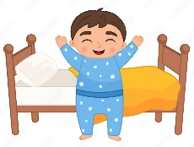 | 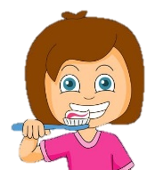 | 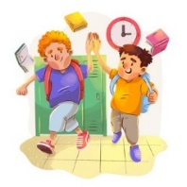 |  |  | 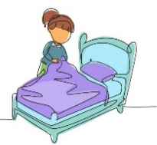 | 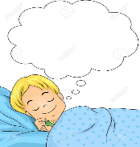
jump out of bed | brush my teeth | finish school | ride the bus | meet friends | jump into bed | dream
- Match the questions with the answers :

1- What time is it ? |  | I usually go to bed at 9:00.
2- What time do you go to bed? |  | Yes , I do.
3- Do you like cheese? |  | It’s nine twenty.

- Match sentences with pictures:

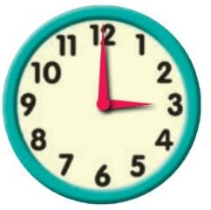  1 | 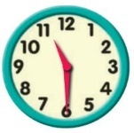  2 | 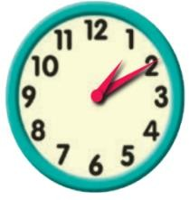  3 | 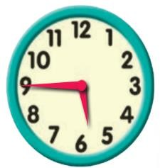    4
( )  It’s six forty five | ( )  It’s one ten | ( )  It’s eleven thirty. | ( )  It’s three o’clock

- copy :

Sleep early to be healthy.

U5: Yesterday & Today Phonics Date: / /1445H

- Fill in the missing letter :

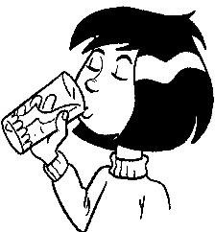 |  |  |  | 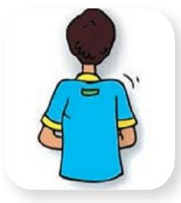 | 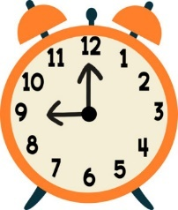
dri _ _ | spri _ _ | i _ _ | ri_ _ | ba _ _ | clo _ _
 | 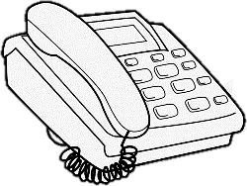 |  |  |  | 
_ _ale | Tele_ _one | _ _ip | _ _ ocolate | _ _ eese | Dol_ _in

2) Unscramble the following to make meaningful paragraph:
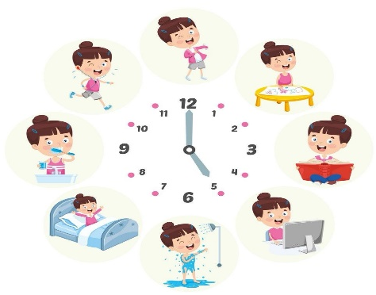

1. get up / at 5 o’clock / I / usually
2. I / to school / go / by bus
3. come home / usually / I/ at 12 o’clock
4. my homework / at 4 o’clock / do / I
5. usually / go to bed / I / at 8 o’clock

……………………………………………………………………………………………………………………………………………………………….
……………………………………………………………………………………………………………………………………………………………….
……………………………………………………………………………………………………………………………………………………………….
……………………………………………………………………………………………………………………………………………………………….
……………………………………………………………………………………………………………………………………………………………….
……………………………………………………………………………………………………………………………………………………………….
……………………………………………………………………………………………………………………………………………………………….
……………………………………………………………………………………………………………………………………………………………….

U6: Jobs Finding out time Date: / /1445H

 |  |  |  | 
doctor | nurse | cook | astronaut | housewife
 |  |  |  | 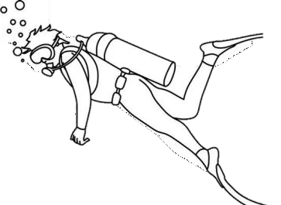
engineer | reporter | architect | pilot | diver
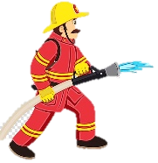 |  |  |  | 
firefighter | teacher | computer technician | businessman | lawyer

- Answer the following question :
1- What does she do ?
She is a .......................................

2- What does he do ?
He is a .........................................

- Copy :

My dad is an engineer.

U6: Jobs Grammar in Action Date: / /1445H

 | 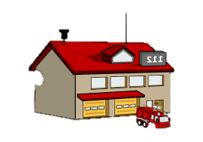 |  | 
restaurant | Fire station | airport | hospital

1) Choose the right answer
1-The doctor works in the……
a- hospital b- school c- restaurant

2-A …………………………….. cooks in the restaurant.
a- nurse b- cook c- firefighter

3-A …………………………….. teaches children.
a- lawyer b- pilot c- teacher

- Match :

Work in the space station |  | 1. Restaurant.
Help sick people |  | 2. firefighters
a place to eat. |  | 3. pilots
Put out fire |  | 4. astronaut
Fly planes |  | 5. doctor

- Copy :

Teachers teach children.

U6: Jobs Rhythms and Reading Date: / /1445H

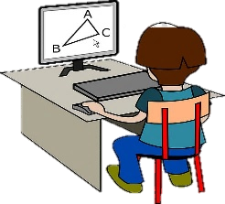 |  |  |  | 
designer | baker | scientist | writer | presenter

- Write about yourself . Answer the following question :

1-What do you want to be when you grow up ?
2- Why ?
3- Where do you want to work?
……………………………………………………………………………………………………………………………………………………………….
……………………………………………………………………………………………………………………………………………………………….
……………………………………………………………………………………………………………………………………………………………….
……………………………………………………………………………………………………………………………………………………………….

- Copy :

When I grow up, I want to be a doctor.

Fill in the missing letter :
U6: Jobs Phonics Date: / /1445H

 |  | 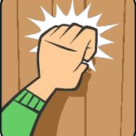 |  |  | 
ri _ _ t | _ _ ife | _ _ock | _ _ob | _ _ee | li _ _t

- Choose the correct pronunciation:

 |  | 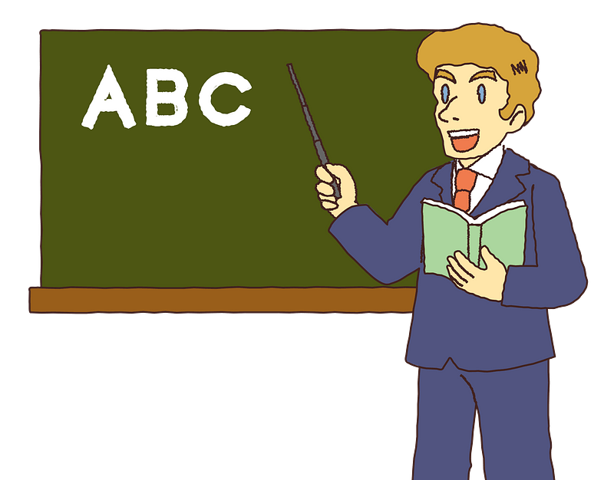 |  |  | 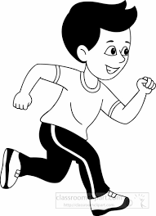
reads | Walks | teaches | washes | eats | runs
/z/  /s/  /iz/ | /z/  /s/  /iz/ | /z/  /s/  /iz/ | /z/  /s/  /iz/ | /z/  /s/  /iz/ | /z/  /s/  /iz/

3) Unscramble the following to make meaningful paragraph:
1. I / when / grow up/ want to be / I / a pilot
2. fly / planes / pilots
3. travel / around / the world / pilots
4. work / they / in / the airport

……………………………………………………………………………………………………………………………………………………………….
……………………………………………………………………………………………………………………………………………………………….
……………………………………………………………………………………………………………………………………………………………….
……………………………………………………………………………………………………………………………………………………………….
……………………………………………………………………………………………………………………………………………………………….
……………………………………………………………………………………………………………………………………………………………….
……………………………………………………………………………………………………………………………………………………………….
……………………………………………………………………………………………………………………………………………………………….

U7: Fun on the Weekend Finding out time Date: / /1445H

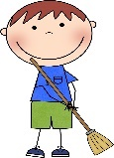 | 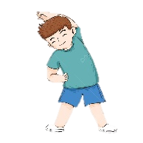 | 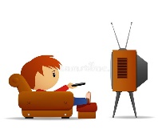 | 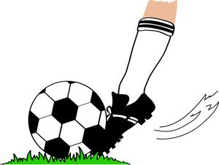 |  | 
clean | practice | watch | kick | study | cook
 | 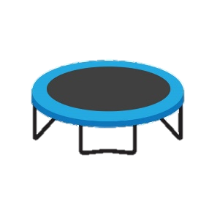 |  |  |  | 
stay home | trampoline | DVD | boring | okay | scary

- Answer the following question :

1- What did you do over the weekend?

................................................................................................................................

2- What did he do in the weekend?
................................................................................................................................

- Copy :

He practiced on the trampoline.

U7: Fun on the Weekend Grammar in Action Date: / /1445H

Regular verbs
cook | cooked
clean | cleaned
watch | watched
practice | practiced
stay | stayed
play | played
study | studied
kick | kicked

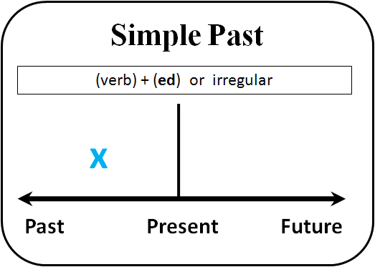

- Choose the correct answer:
1- She ( cooked – cleaned – kicked ) the breakfast . 2- You ( stayed – cooked - watched ) a DVD.
3- We (watched -stayed- kicked ) at home.
- Fill in the blanks using the simple past tense forms of the verbs given in the brackets:
1-I ...............................................(practice) my English.
2-They .......................................(clean) the house.
3- You......................................... (study) a little.
4-You ......................................... (play ) outside.
5- He ..........................................(kick ) a ball.
- Copy :

She cooked a big breakfast.

U7: Fun on the Weekend Reading and writing Date: / /1445H

How many………..? | How much………..? | Some | Any
Countable nouns: we can’t count it. | Uncountable nouns: we can count it. | Affirmative sentence . | Negative sentence .  ( not )
Pens, books, flowers,  tomatoes | Flour, oil, cheese | We have some flour. | We don’t have any oil.

How many | pens  books  flowers  tomatoes | do | I  you  we  they | want?  need?  have?
How much | flour  oil  cheese | does | he  she  it | want?  need?  have?

- Choose the right verb :
1- How ( much –many –old ) flour do you want?
2- How ( much –many –old ) tomatoes does she have?
3- How (much –many –old ) peppers do you need?
4- How (much –many –old ) mushrooms do we need?
5- How ( much –many –old ) oil do you want?
6- We have ( any –some ) eggs in the fridge.
7- I don't have ( any –some ) flour.
8- We don’t have ( any –some ) oil.

- Copy :

I’d like fruit sald, please.

U7: Fun on the Weekend Phonics Date: / /1445H

Fill in the missing letter :
 | 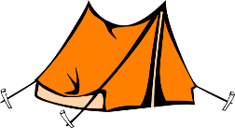 | 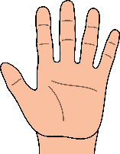 |  | 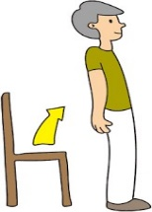 | 
sa _ _ | te_ _ | ha_ _ | pai_ _ | sta_ _ | pla _ _

Write the correct word under the correct column:

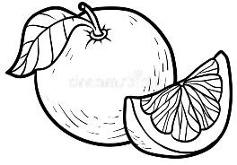 |  | 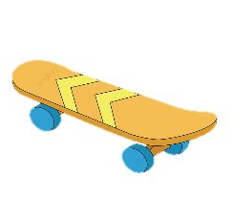 |  | 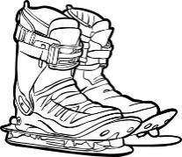 | 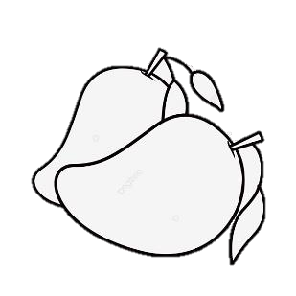
grapefruit | coat | skateboard | Suit | Ski boots | mangoes

fruit store | sport store | clothing store

Match :
1- You can buy suits at……. |  | a sport store.
2- What would you like? |  | Yes, please.
3- You can buy mangoes at…….. |  | a clothing store.
4-What did you do over the weekend? |  | I’d like salad please.
5-You can buy ski boots at…….. |  | a fruit store.
 |  | I cooked a big breakfast

U8: Life’s Up and Down Finding out time Date: / /1445H

 |  |  | 
won the game | got first place | lost game | caught a cold
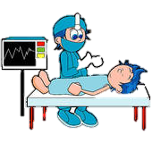 |  | 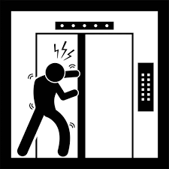 | 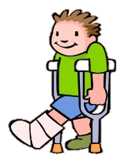
had an operation | make a rocket | Stuck in an elevator | broke my leg

1) Choose the right answer
1-What good thing happened to you last year?
a- I caught a cold. b- I lost game. c- I got the first place in school

2- What bad thing happened to you last year?
a- I broke my leg. b- I made a rocket. c- I won the race.

2) Copy :

I got first place in a race.

U8: Life’s Up and Down Grammar in Action Date: / /1445H

1) Write the past form of the verbs
Verb | Past form | Verb | Past form
1-lose |  | 6-make
2-win |  | 7-see
3-get |  | 8-catch
4-is |  | 9-have/has
5-are |  | 10-break

2) Match pictures with sentences

  1 | 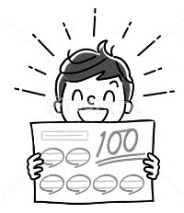  2 | 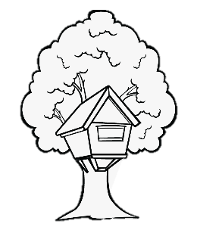  3 | 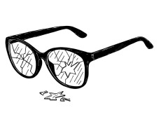  4 | 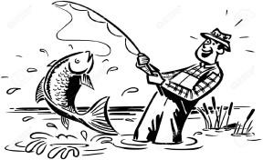  5
( )  I caught a big fish. | ( )  I broke my glasses. | ( )  I made a tree house. | ( )  I got 100 points. | ( )  We won a football game.

3) Copy :

We were happy.

U8: Life’s Up and Down Reading and Writing Date: / /1445H

 | 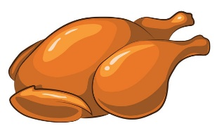 | 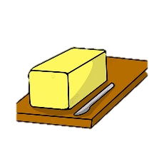
meat | chicken | Butter | 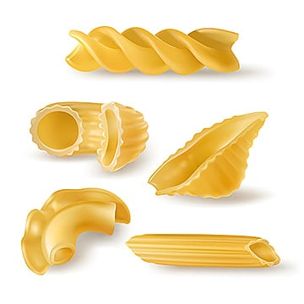  macaroni
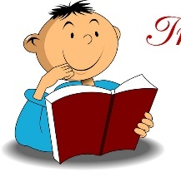 | 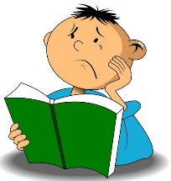 | 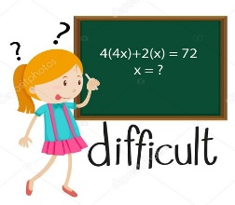 | 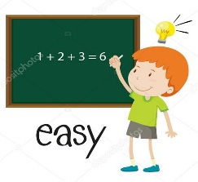
interesting | boring | difficult | easy

1) Write the past form of the verbs
Verb | Past tens | Verb | Past tens
1-go |  | 2- come

2) Copy :

I think it’s funny.

U8: Life’s Up and Down Phonics Date: / /1445H

Subject pronouns | Object pronouns
I | me
She | her
He | him
we | us
They | them
You | you

Fill in the missing letter :
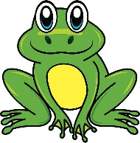 |  |  |  |  | 
_rog | _ _one | lau_ _ | _ riends | _ _oto | ele _ _ ant

2) Change the underlined words :

1- He saw Ali .
2- He saw Sara.
3- She saw the teacher.
4- She saw the girls.

3) Choose the correct words :
1- Yesterday,( we – us – me ) went to an adventure park.
2- I saw my friends and played with ( him – he -them).
3- She calls ( I – me – we).
4- I met ( her- she – they) in the school.

My verbs list

Verb | Past form | Verb | Past form

